**Dormzz : Hostel Management System**

A project submitted to

**UKA TARSADIA UNIVERSITY**

in partial fulfillment of the requirements for the degree of

**Bachelor of Science**

in

**Information Technology**

for

**5 Years Integrated M.Sc.(IT)**

By

**Parth Desai**

(202003103410001)

**Pooja Patel**

(202006100110037)

Guided by

**Dr. Sapan Naik**

**Assistant Professor**



**Babu Madhav Institute of Information Technology**

**Uka Tarsadia University**

**Bardoli – 394350**

**December 2020**

**CERTIFICATE**

This is to certify that **Parth Desai (202003103410001) and Pooja Patel (202003103410001)** has submitted project entitled **“Dormzz : Hostel Management System”** as the partial fulfillment for the award of the degree of Bachelor of Science in Information Technology for 5 Years Integrated M.Sc.(IT) in 2020 – 2021.

**Date: 10/12/2022**

**Place: BMIIT, UTU, Bardoli**

**Mr. Sapan Naik Dr. Jitendra Nasriwala**

Guide Programme Coordinator,

**External Examiner**



**Babu Madhav Institute of Information Technology,**

**Uka Tarsadia University,**

**Bardoli – 394350**

**Table of Content**

|  |  |  |  |  |
| --- | --- | --- | --- | --- |
| **Chapters** | **Particulars** | | | **Page no.** |
| **1** | **Introduction** | | |  |
| 1.1 | Problem Definition | |  |
| 1.2 | Project Objective | |  |
| 1.3 | Product Scope | |  |
|  | | | | |
| **2** | **Overall Description** | | |  |
| 2.1 | Product Perspective/ Environment Description | |  |
|  | 2.1.1 | Hardware Interface/ Hardware Specification |  |
|  | 2.1.2 | Software Interface/ Software Specification |  |
|  | | | | |
| **3** | **System Specific Requirements** | | |  |
| 3.1 | Functional Requirement | |  |
| 3.2 | Non-functional Requirement | |  |
|  | | | | |
| **4** | **System Design** | | |  |
| 4.1 | Database Design | |  |
| 4.1.1 | Database Schema |  |
| 4.1.2 | Data Dictionary |  |
|  | | | | |
| **5** | **System Implementation** | | |  |
| 5.1 | Screenshots | |  |
|  | | | | |
| **6** | **Testing** | | |  |
| 6.1 | Test Cases | |  |
|  | | | | |
| **7** | **Future Enhancement** | | |  |
|  |  | | |  |
|  | **Conclusion** | | |  |
|  |  | | |  |
|  | **Bibliography** | | |  |

**List of Figures**

|  |  |  |
| --- | --- | --- |
| **Figure no.** | **Figure Description** | **Page no.** |
| **5.1.1** | **Use Case Diagram for Admin** |  |
| **5.1.2** |  |  |
| **5.1.3** |  |  |
| **5.2.1** | **Activity Diagram for Manage Product** |  |
| **5.2.2** |  |  |
| **5.2.3** |  |  |
| **5.2.4** |  |  |
| **5.2.5** |  |  |
| **5.3.1** | **Sequence Diagram for “adding a product”** |  |

**List of Tables**

|  |  |  |
| --- | --- | --- |
| **Table no.** | **Table Description** | **Page no.** |
|  | Data Dictionary Tables | 50 - 60 |
| 8.1.1 | Test Cases for Register |  |
| 8.1.2 | Test Cases for Login |  |
| 8.1.3 | Test Cases for Add / Update Staff Member |  |
| 8.1.4 | Test Cases for Assign Designation |  |
| 8.1.5 | Test Cases for Room-Map |  |

**1.Introduction**

**1.1 Problem Definition**

A Hostel/Chain of Hostel is an essential part of an Institute along with educational curriculum. Every year hundreds of students takes admission and decides to stay in Hostel. It Provides a space to students who are unable to travel a lot or who are living much far away from the institute or are unaware of the surroundings to live with. The best hostel management systems not only allow the admin, owner or staff members to manage the various aspects of the business from one location, they offer the possibility for employees to access the system remotely, and the information that is updated within the system to all the employees automatically.

Finding a PG is not easy sometimes because there are lots of essential tasks that are needed to be done in order to finalize a place to live-in such as finding a good PG situated not very far from the institute, availability of the life essential things, amenities etc. and importantly, living in a Hostel helps students save their traveling time and utilize this time into many different useful areas. Therefore, a good platform must be required to provide all the useful privileges to find a Hostel and book a place that comforts them.

**1.2 Project Definition / Objective**

Dormzz: The Hostel Management System allows to use wide range of loaded features online which are usually not provided to the students or staff members due to unapproachable resources. Given below are the key features of the system that the students and staff will be able to use:

* Booking Rooms
* Online Payment
* Saving Transportation Time
* Daily Activities and Games
* Cleanliness and Hygiene
* Counseling
* Events
* Proper Maintained Schedule
* Immediate Health assist/support.

**1.3 Scope / Boundaries**

The Scope of the system is limited to the stack holders of the Uka Tarsadia University, Bardoli. Viz. Admin, Staff and Students. This system is designed to be used for the long period of time over the number of new batches.

**2. Overall Description**

**2.1 Product Perspective / Environment Description**

**2.1.1 Hardware Interface / Hardware Specification**

|  |  |
| --- | --- |
| Device name | PARTHs-DESKTOP |
| Processor | Intel(R) Core (TM) i5-1035G1 CPU @ 1.00GHz 1.19 GHz |
| Installed RAM | 16.0 GB |
| System type | 64-bit operating system, x64-based processor |
| Hard Disk | 512 GB |

**2.1.2 Software Interface / Software Specification**

|  |  |
| --- | --- |
| Operating System | Microsoft Windows 11 |
| Front End | HTML, CSS, JS, Bootstrap |
| Back End | Mysql, Php |
| Input Device | Keyboard, Mouse |
| Output Device | Monitor, Printer |
| Software Used | Visual Studio Code (Version 1.69.0), Apache NetBeans IDE 14 |
| Tools | Xampp (Version 3.3.0) |

**3. System Specific Requirements**

**3.1 Functional Requirements**

* Registration
* Login
* Add contact details
* View Dashboard
* Add / Update Posts/Notices
* Manage User Profiles (All users)
* Manage Packages
* Manage Rooms
* Book Rooms
* Manage Mess Information
* Manage Events / Activities
* Manage Leaves
* Manage Requests
* Manage Complains
* Manage Duties
* View Feedbacks, Ratings, Portfolio

**3.2 Non-Functional Requirements**

* Security : The System will be able to Manage stored Payment Options
* Reliability : The System will be reliable on Enrollment Number and Institute Id.
* Compatibility : The System will be compatible with different OS and Devices.
* Useability : The System will be able to Provide Easy-to-Use Interface to for Users.
* Availability : The System will be able to provide all the necessary data under regular traffic as well as critical situations.
* Simplicity : The System will be able to perform simple tasks and Operations.

**4. System Design**

**4.1 Database Design :**

**4.1.1 Database Schema**

1. Table Name : tblRegister

tblRegister (user_id[PK], EnrollmentNo, CourseName, DepartmentName, Username, Password, FirstName, LastName, Gender, Email, PhoneNo)

1. Table Name : tblStudent

tblStudent (user_id[PK], Club_id[FK], Profile_img)

1. Table Name : tblStaff

tblStaff (user_id[PK], role_id[FK],)

1. Table Name : tblRole

tblRole(Role_id[PK], Role_type)

1. Table Name : tblUserType

tblType (UType_id[PK], UType)

1. Table Name : tblHostel

tblHostel (Hostel_id[PK], Capacity, Hostel_Name, Hostel_Category, Hostel_Status, Hostel_Distance, Hostel_Type, Available_Rooms, user_id[FK], Mess_ID[FK], Address, Hostel_Floor, Hostel_Map)

1. Table Name : tblRoom

tblRoom (Room_id[PK], Room_Type_id[FK], Hostel_id[FK])

1. Table Name : tblRoomType

tblRoom (Room_Type_id[PK], Room_Type, Room_Capacity, Room_Facilities_id[FK])

1. Table Name : tblRoomFacilities

tblRoomFacilities (Room_Facilities_id[PK], Room_Facilities)

1. Table Name : tblMess

tblMess(Mess_id[PK], Mess_Name, user_id[FK], Hostel_id[FK], MessMenu_id[FK])

1. Table Name : tblMess_Menu

tblMess_Menu(MessMenu_id[PK], Menu_Day, Menu_Time, Dish_id[FK])

1. Table Name : tblDish

tblMess(Dish_id[PK], DishName)

1. Table Name : tblPackage

tblPackage (Package_id[PK], Package_Name, Package_Description, Package_Price, Package_Valid_From, Package_Valid_To)

1. Table Name : tblHostel_Record

tblHostel_Record (Record_id[PK], user_id[FK], Hostel_id[FK], Room_id[FK], Room_Type_id[FK], Timestamp_Check_Out, Timestamp_Check_In, User_Status)

1. Table Name : tblTransaction

tblTransaction (Trn_id[PK], user_id[FK], Record_id[FK], Package_id[FK], Trn_Timestamp, Trn_Amount, Trn_Mode, Trn_refference_id, Trn_Status)

1. Table Name : tblComplain

tblComplain (Cmp_id[PK], Cmp_Type_id[FK], user_id[FK], Cmp_Timestamp, Cmp_Brief, Cmp_Remarks, Cmp_Status, Cmp_ClosedBy, Cmp_UpdatedTS)

1. Table Name : tblComplain_Type

tblComplain_Type ( Cmp_Type_id[PK], Cmp_Type, ReC_Type)

1. Table Name : tblRequest

tblRequest (Req_id[PK], Req_Type_id, user_id[FK], Req_Timestamp, Req_Brief, Req_Remarks, Req_Status, Req_UpdatedBy, Req_UpdatedTS)

1. Table Name : tblFeedback

tblFeedback (Fdb_id[PK], user_id, Fdb_Timestamp, Fdb_Brief)

1. Table Name : tblEvent

tblEvent (Event_id[PK], Event_Name, Event_Date)

1. Table Name : tblClub

tblClub (Club_id[PK], Club_Name, user_id, Event_id)

1. Table Name : tblNotice

tblNotice (Notice_id[PK], Notice_Brief, user_id, Notice_Timestamp )

1. Table Name : tblLeave

tblLeave (Leave_id[PK], user_id[FK], Leave_Reason, Leave_From, Leave_To, Leave_Status, Leave_Remarks, Leave_ApprovedBy)

**4.1.2 Data Dictionary**

1. Table Name : tblRegister

|  |  |  |  |  |
| --- | --- | --- | --- | --- |
| tblRegister | | | | |
| Field Name | Datatype | Size | Constraint | Description |
| user_id | int | 7 | Primary Key | Unique id of Users |
| EnrollmentNo | big int | 9 | Not Null | Enrollment Numbers of User |
| CourseName | Varchar | 500 | Not Null | Current Course Pursuing |
| DepartmentName | Varchar | 500 | Not Null | Department Name |
| Username | Varchar | 100 | Not Null | User Account id |
| Password | Varchar | 255 | Not Null | User Account Password |
| FirstName | Varchar | 100 | Not Null | First Name of the User |
| LastName | Varchar | 100 | Not Null | Last Name of the User |
| Gender | Varchar | 10 | Not Null | Gender of User |
| Email | Varchar | 500 | Not Null | Email id of the User |
| PhoneNo | Numeric | 10 | Not Null | Phone number of the User |

1. Table Name : tblStudent

|  |  |  |  |  |
| --- | --- | --- | --- | --- |
| tblStudent | | | | |
| Field Name | Datatype | Size | Constraint | Description |
| user_id | int | 7 | Primary Key | Unique id of Users |
| Club_id | int | 6 | Foreign Key | Unique id of Club |
| Profile_img | Varchar | 800 | ./Image/default_profile.jpeg | Default Path of Profile Pic |

1. Table Name : tblStaff

|  |  |  |  |  |
| --- | --- | --- | --- | --- |
| tblStaff | | | | |
| Field Name | Datatype | Size | Constraint | Description |
| user_id | int | 7 | Primary Key | Unique id of Users |
| Role_id | int | 5 | Foreign Key | Unique id of Role |
| Hostel_id | Bigint | 7 | Foreign Key | Id of Hostel |

1. Table Name : tblRole

|  |  |  |  |  |
| --- | --- | --- | --- | --- |
| tblRole | | | | |
| Field Name | Datatype | Size | Constraint | Description |
| Role_id | Int | 5 | Primary Key | Unique id of Role Type |
| Role_Type | Varchar | 100 | Not Null | Type of Role |

1. Table Name : tblHostel

|  |  |  |  |  |
| --- | --- | --- | --- | --- |
| tblHostel | | | | |
| Field Name | Datatype | Size | Constraint | Description |
| Hostel_id | Int | 7 | Primary Key | Unique id of Hostel |
| Capacity | Int | 3 | Not Null | Capacity of a Hostel |
| Hostel_Name | Varchar | 500 | Not Null | Name of the Hostel |
| Hostel_Category | Varchar | 50 | Not Null | Category of Hostel (Male/Female) |
| Hostel_Status | Varchar | 100 | Not Null | Status of Hostel |
| Hostel_Distance | Varchar | 10 | Not Null | Distance of Hostel from Campus |
| Hostel_Type | Varchar | 200 | Not Null | Type of Hostel |
| Available_Rooms | Int | 100 | Not Null | Availability of the Rooms |
| user_id | Int | 7 | Foreign Key | Unique Staff id of Rector |
| Mess_id | Int | 3 | Foreign Key | Unique Mess id of Mess |
| Address | Varchar | 500 | Not Null | Address of the Hostel |
| Hostel_Floor | Int | 3 | Not Null | Number of Floor of Hostel |
| Hostel_Map | LongText | 65000 | Not Null | Map of Rooms of Hostel |

1. Table Name : tblRoom

|  |  |  |  |  |
| --- | --- | --- | --- | --- |
| tblRoom | | | | |
| Field Name | Datatype | Size | Constraint | Description |
| Room_id | Int | 5 | Primary Key | Unique id of Room |
| Room_Type_id | Varchar | 4 | Foreign Key | Unique id of Room Type |
| Hostel_id | int | 7 | Foreign Key | Unique id of Hostel |

1. Table Name : tblRoomType

|  |  |  |  |  |
| --- | --- | --- | --- | --- |
| tblRoomType | | | | |
| Field Name | Datatype | Size | Constraint | Description |
| Room_Type_id | Int | 5 | Primary Key | Unique id of Room Type |
| Room_Type | Varchar | 20 | Not null | Type of Room |
| Room_Capacity | int | 2 | Not null | Capacity of the Room |
| Room_Facilities_id | Varchar | 250 | Foreign Key | Unique id of Facilities Provided |

1. Table Name : tblRoomFacilities

|  |  |  |  |  |
| --- | --- | --- | --- | --- |
| tblRoomFacilities | | | | |
| Field Name | Datatype | Size | Constraint | Description |
| Room_Facilities_id | Int | 5 | Primary Key | Unique id of Facilities Provided |
| Room_Facilities | Varchar | 80 | Not Null | Facilities Provided in Rooms |

1. Table Name : tblMess

|  |  |  |  |  |
| --- | --- | --- | --- | --- |
| tblMess | | | | |
| Field Name | Datatype | Size | Constraint | Description |
| Mess_id | int | 3 | Primary Key | Unique id of Mess |
| Cateres_Name | Varchar | 500 | Not Null | Name of Mess Cateres |
| user_id | Big Int | 7 | Foreign Key | Unique id of Staff Members only |
| Hostel_id | Big Int | 7 | Foreign Key | Unique id of Hostel |
| MessMenu_id | Big Int | 5 | Foreign Key | Unique id of Mess Menu |

1. Table Name : tblMess_Menu

|  |  |  |  |  |
| --- | --- | --- | --- | --- |
| tblMess_Menu | | | | |
| Field Name | Datatype | Size | Constraint | Description |
| MessMenu_id | Int | 5 | Primary Key | Unique id of Mess Menu |
| Menu_Day | Date |  | Not Null | Day of Menu Applicable |
| Menu_Time | Time |  | Not Null | Time of Day Menu Applicable |
| Dish_id | Varchar | 10000 | Foreign Key | Unique id of Dishes |

1. Table Name : tblDish

|  |  |  |  |  |
| --- | --- | --- | --- | --- |
| tblDish | | | | |
| Field Name | Datatype | Size | Constraint | Description |
| Dish_id | Big Int | 6 | Primary Key | Unique id of Dishes |
| DishName | Varchar | 800 | Not Null | Name of Dishes |

1. Table Name : tblPackage

|  |  |  |  |  |
| --- | --- | --- | --- | --- |
| tblPackage | | | | |
| Field Name | Datatype | Size | Constraint | Description |
| Package_id | Big Int | 7 | Primary Key | Unique id of Packages |
| Package_Name | Varchar | 50 | Not Null | Name of Package |
| Package_Description | Varchar | 900 | Not Null | Description about Package |
| Package_Price | Big Int | 7 | Not Null | Price of Package |
| Package_Valid_From | Date |  | Not Null | Date of Package Validity |
| Package_Valid_To | Date |  | Not Null | Expiry Date of Package |

1. Table Name : tblHostel_Record

|  |  |  |  |  |
| --- | --- | --- | --- | --- |
| tblHostel_Record | | | | |
| Field Name | Datatype | Size | Constraint | Description |
| Record_id | Big Int | 10 | Primary Key | Unique id of Hostel Record |
| Trn_id | Big Int | 12 | Null | Id of Transactions |
| user_id | Int | 7 | Foreign Key | Unique id of Users |
| Hostel_id | Int | 7 | Foreign Key | Id of Hostel |
| Room_id | Int | 5 | Foreign Key | Unique id of Room |
| Timestamp_Check_Out | DateTime |  | Not Null | Timestamp of Check out |
| Timestamp_Check_In | DateTime |  | Not Null | Timestamp of Check in |
| User_Status | Varchar | 7 | Not Null | Status of User Account |

1. Table Name : tblTransaction

|  |  |  |  |  |
| --- | --- | --- | --- | --- |
| tblTransaction | | | | |
| Field Name | Datatype | Size | Constraint | Description |
| Trn_id | Big Int | 12 | Primary Key | Unique id of Transaction |
| user_id | Big int | 7 | Foreign Key | Unique id of Users |
| Record_id | Big Int | 10 | Foreign Key | Unique id of Hostel Record |
| Trn_Timestamp | Date |  | Current TS | Timestamp of Transaction |
| Trn_Amount | Double |  | Not Null | Amount of Hostel Fees / Package |
| Trn_Mode | Varchar | 200 | Not Null | Mode of Transaction / Payment |
| Trn_refference_id | Varchar | 15 | Not Null | Reference number of Transaction |
| Trn_Status | Varchar | 200 | Not Null | Status of the Transaction |

1. Table Name : tblComplain_Type

|  |  |  |  |  |
| --- | --- | --- | --- | --- |
| tblComplain_Type | | | | |
| Field Name | Datatype | Size | Constraint | Description |
| Cmp_Type_id | Big Int | 5 | Primary Key | Unique id of Complain Type |
| Cmp_Type | Varchar | 50 | Not Null | SubType of Complain |
| ReC_Type | Varchar | 50 | Not Null | Type of Complain |

1. Table Name : tblComplain

|  |  |  |  |  |
| --- | --- | --- | --- | --- |
| tblComplain | | | | |
| Field Name | Datatype | Size | Constraint | Description |
| Cmp_id | Big Int | 9 | Primary Key | Unique id of Complain |
| Cmp_Type_id | Big Int | 5 | Foreign Key | Unique id of type of Complain |
| user_id | Big Int | 7 | Foreign Key | Unique id of Users |
| Cmp_Timestamp | DateTime |  | Current TS | Timestamp of Complain Generated |
| Cmp_Brief | Varchar | 500 | Not Null | Complain in Brief |
| Cmp_Remarks | Varchar | 500 | Null | Reply of the Complain |
| Cmp_Status | Varchar | 50 | Not Null | Status of the Complain |
| Cmp_ClosedBy | Big Int | 7 | Null | Id of staff who closed complain |
| Cmp_UpdatedTS | Timestamp |  | Current | Current TimeStamp |

1. Table Name : tblRequest

|  |  |  |  |  |
| --- | --- | --- | --- | --- |
| tblRequest | | | | |
| Field Name | Datatype | Size | Constraint | Description |
| Req_id | Big Int | 9 | Primary Key | Unique id of Request |
| Req_Type_id | Big Int | 5 | Foreign Key | Id of SubRequest Type |
| user_id | Big Int | 7 | Foreign Key | Unique id of Users |
| Req_Timestamp | DateTime |  | Not Null | Timestamp of Request Generated |
| Req_Brief | Varchar | 500 | Not Null | User Account Password |
| Req_Remarks | Varchar | 500 | Null | Reply of the Request |
| Req_Status | Varchar | 50 | Not Null | Status of the Request |
| Req_UpdatedBy | Big Int | 7 | Not Null | Id of staff who updated request |
| Req_UpdatedTS | TimeStamp |  | Not Null | Current TimeStamp |

1. Table Name : tblFeedback

|  |  |  |  |  |
| --- | --- | --- | --- | --- |
| tblFeedback | | | | |
| Field Name | Datatype | Size | Constraint | Description |
| Fdb_id | Big Int | 9 | Primary Key | Unique id of Feedback |
| user_id | Big Int | 7 | Primary Key | Unique id of Users |
| Fdb_Timestamp | DateTime |  | Not Null | Feedback Timestamp |
| Fdb_Brief | Varchar | 800 | Not Null | Feedback of the User |

1. Table Name : tblEvent

|  |  |  |  |  |
| --- | --- | --- | --- | --- |
| tblEvent | | | | |
| Field Name | Datatype | Size | Constraint | Description |
| Event_id | Big Int | 8 | Primary Key | Unique id of Events |
| Event_Name | Varchar | Max | Not Null | Name of the Event |
| Event_Date | DateTime |  | Not Null | Date and Time of the Event |

1. Table Name : tblClub

|  |  |  |  |  |
| --- | --- | --- | --- | --- |
| tblClub | | | | |
| Field Name | Datatype | Size | Constraint | Description |
| Club_id | Big Int | 7 | Primary Key | Unique id of Club |
| Club_Name | Varchar | 100 | Not Null | Name of the Club |
| user_id | Big Int | 7 | Foreign Key | Unique id of Users |
| staff_id | Big Int | 7 | Foreign Key | Unique id of Staff Member |

1. Table Name : tblNotice

|  |  |  |  |  |
| --- | --- | --- | --- | --- |
| tblNotice | | | | |
| Field Name | Datatype | Size | Constraint | Description |
| Notice_id | Big Int | 9 | Primary Key | Unique id of Notice |
| Notice_Brief | Varchar | Max | Not Null | Notice in Brief |
| user_id | Big Int | 7 | Foreign Key | Unique id of Users |
| Notice_Timestamp | Datetime |  | Not Null | Timestamp of Notice Generated |

1. Table Name : tblLeave

|  |  |  |  |  |
| --- | --- | --- | --- | --- |
| tblLeave | | | | |
| Field Name | Datatype | Size | Constraint | Description |
| Leave_id | Big Int | 9 | Primary Key | Unique id of Blog |
| User_id | Big Int | 7 | Foreign Key | Unique id of User |
| Leave_Reason | Varchar | 100 | Not Null | Title of the Blog |
| Leave_From | DateTime |  | Not Null | Timestamp of Leave Starting Day |
| Leave_To | DateTime |  | Not Null | Timestamp of Leave Ending Day |
| Leave_Status | Varchar | 10 | Not Null | Status of the Leave |
| Leave_Remarks | Varchar | 500 | Null | Remarks of Staff regarding leave |
| Leave_ApprovedBy | Big Int | 7 | Null | Id of Staff who approved Leave |

**5. System Implementation**

**5.1 Screenshots :**

**1. Registration Page :**

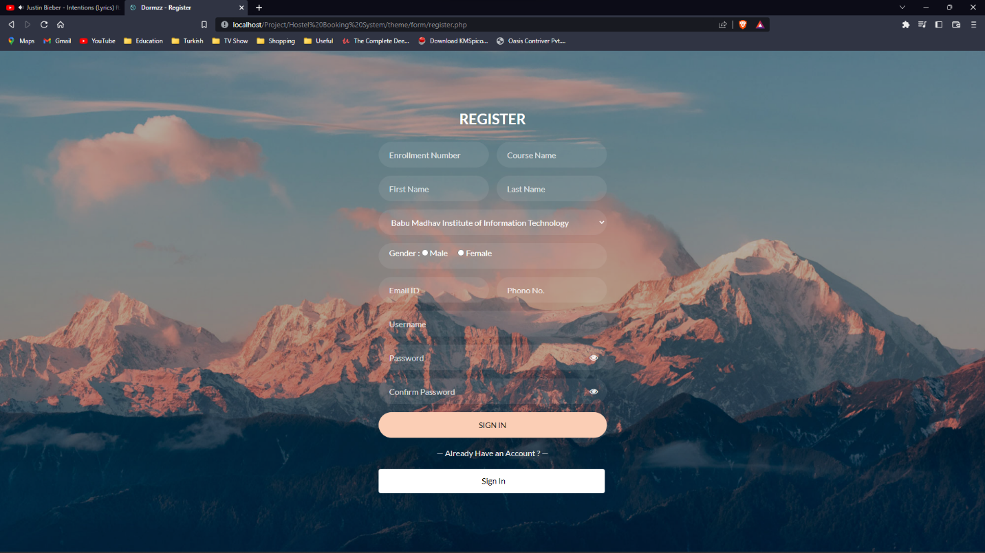

**6. Room Booking :** 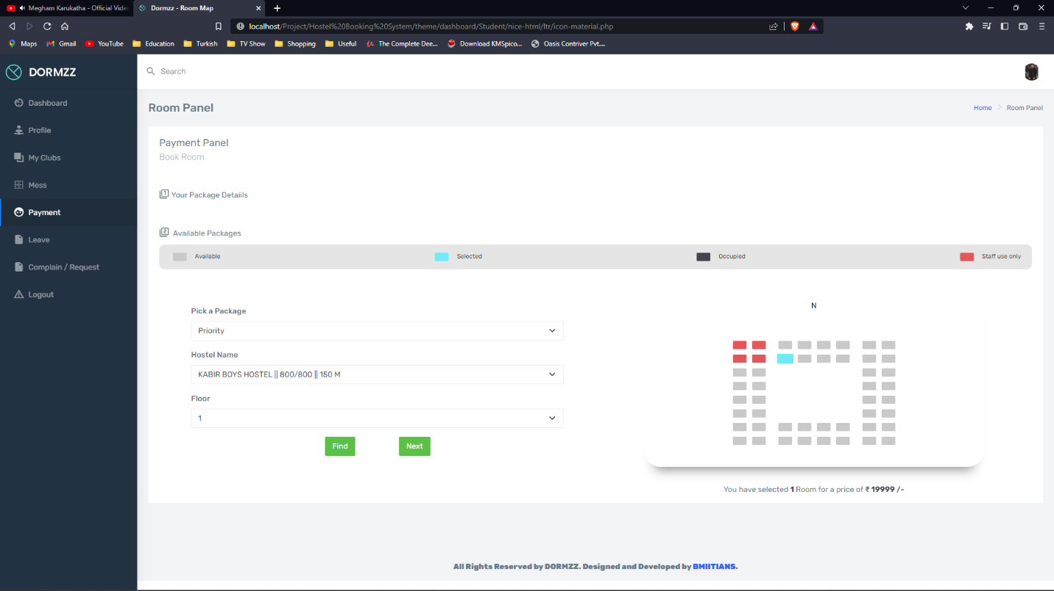

**7. Student Leave Panel :** 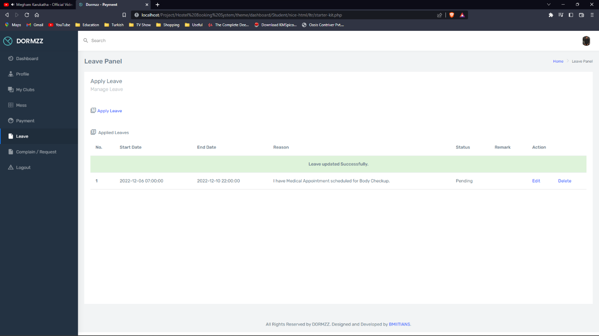

**3. Student Mess Panel :** 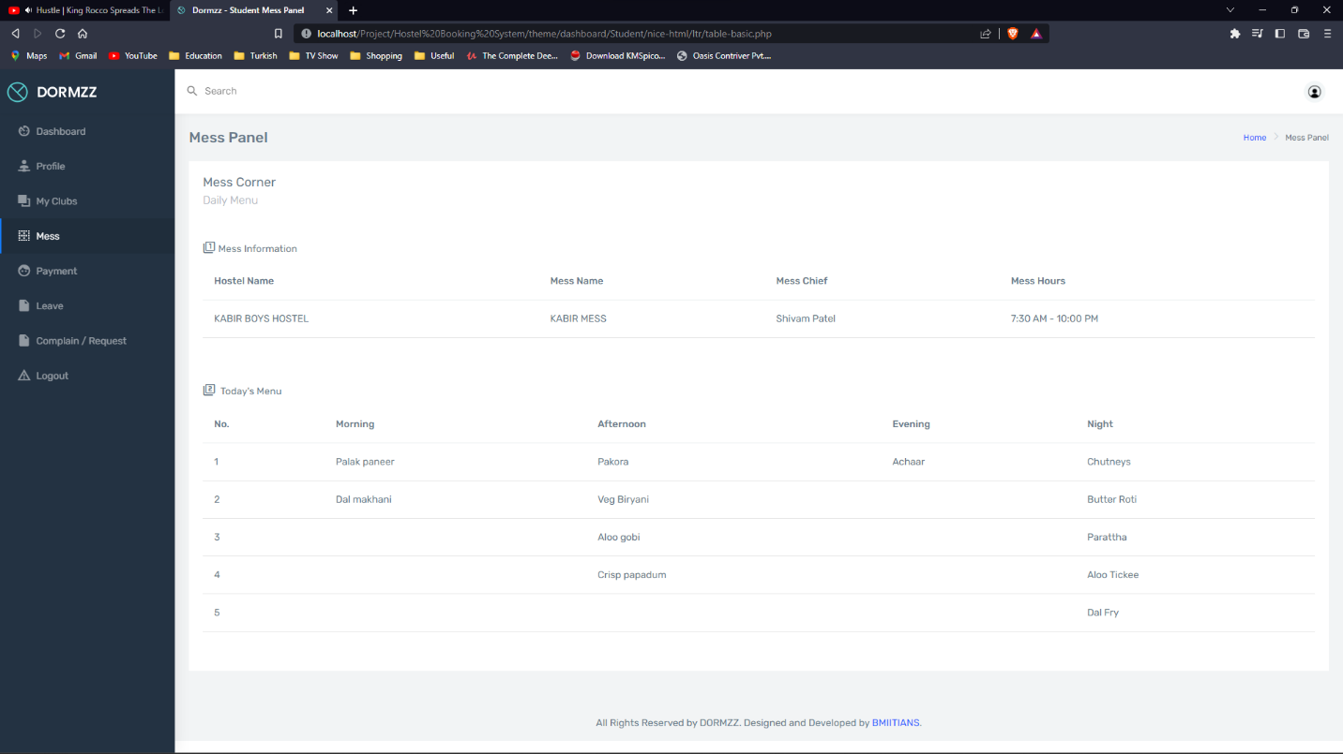

**5.1.1 Use-case Diagram :**

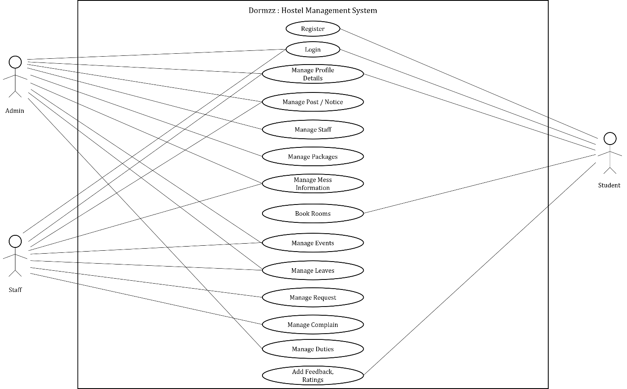

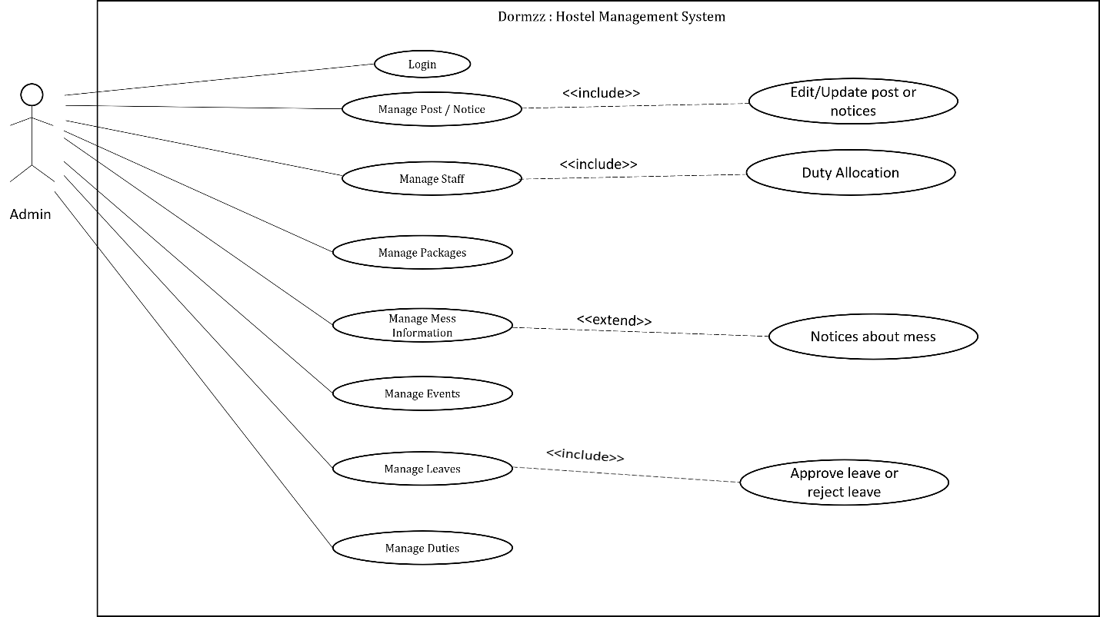

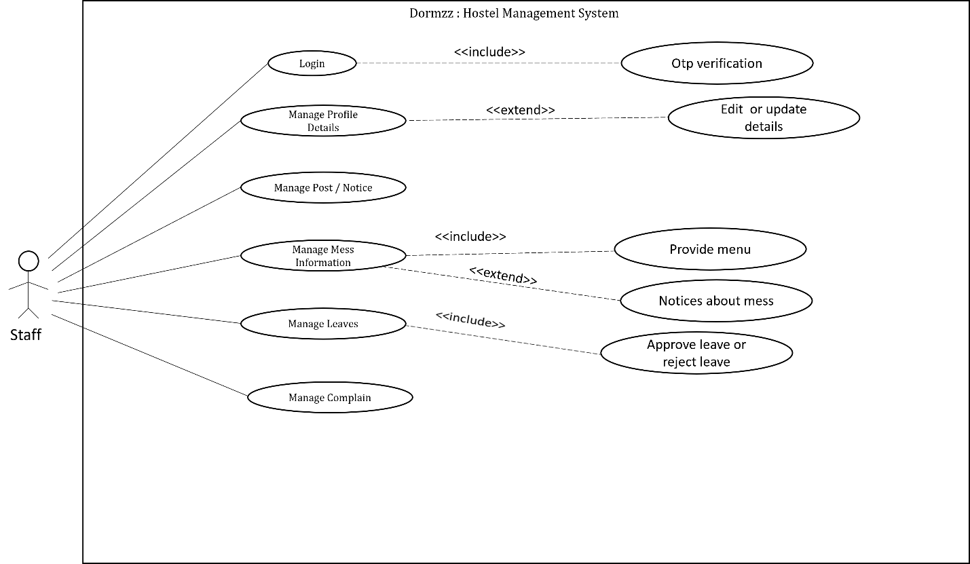

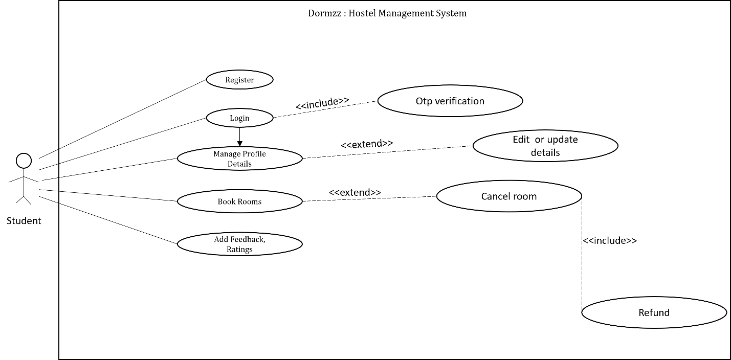

**5.2.1 Activity Diagram :**

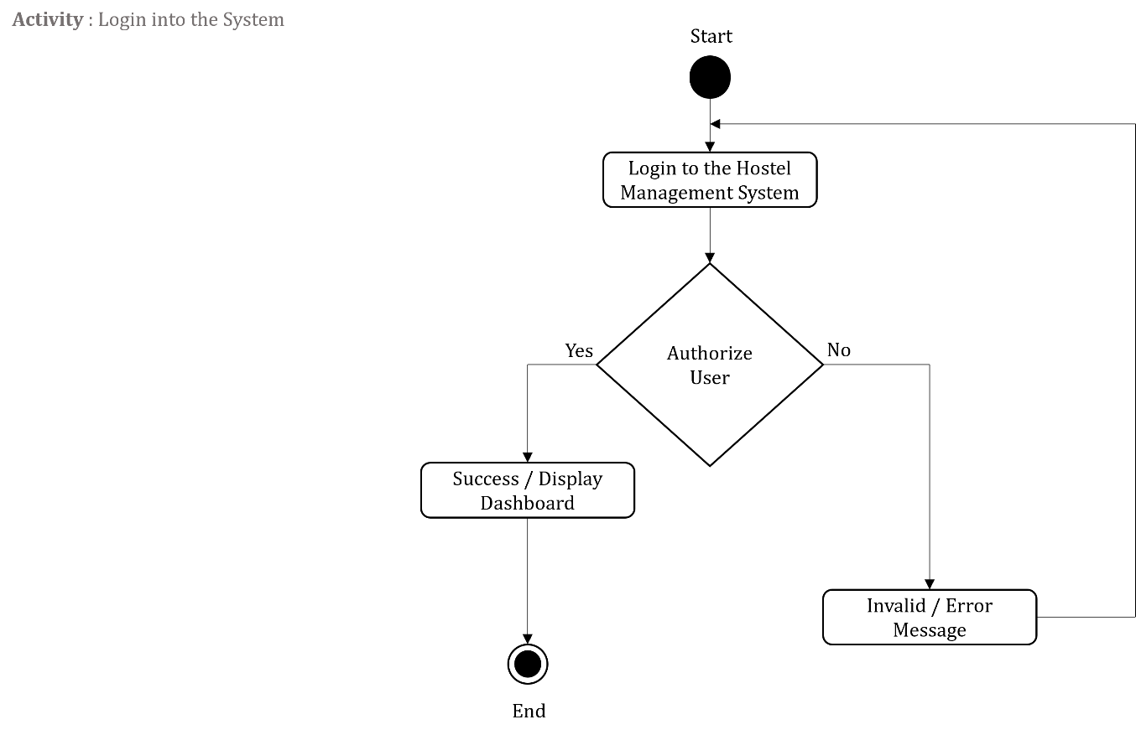

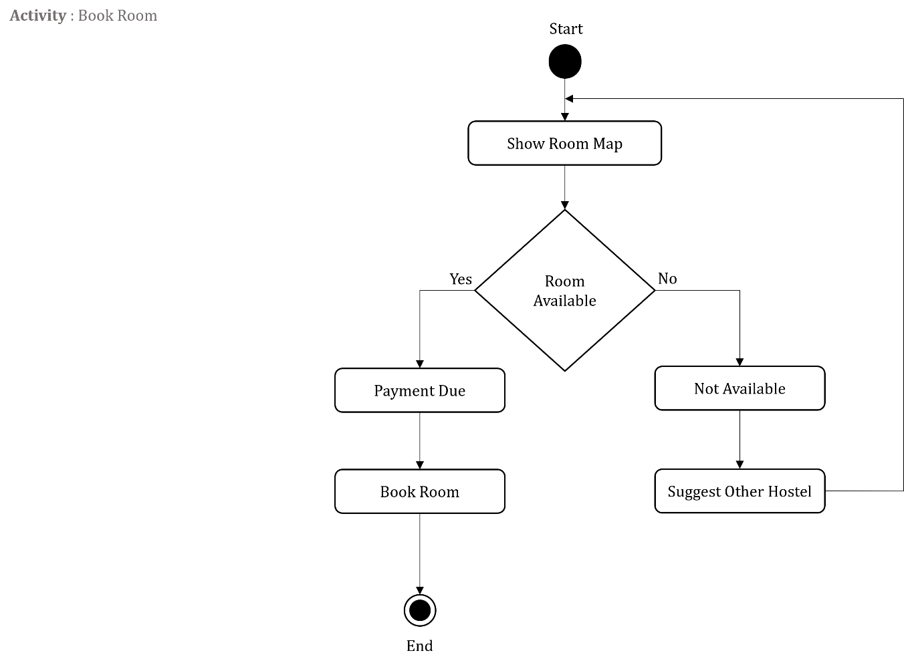

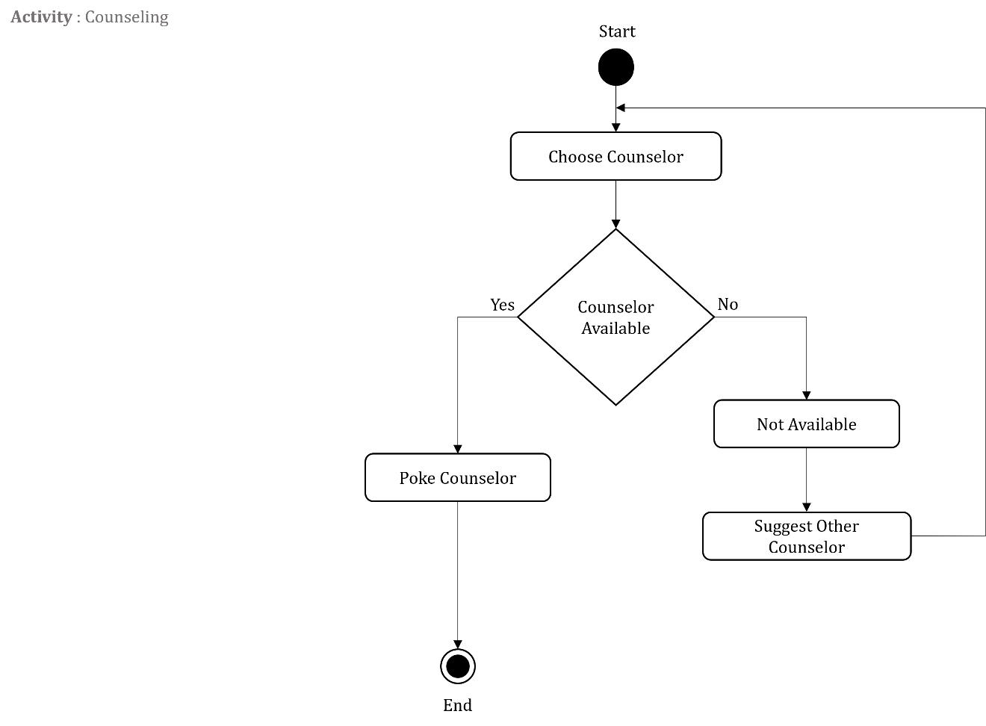

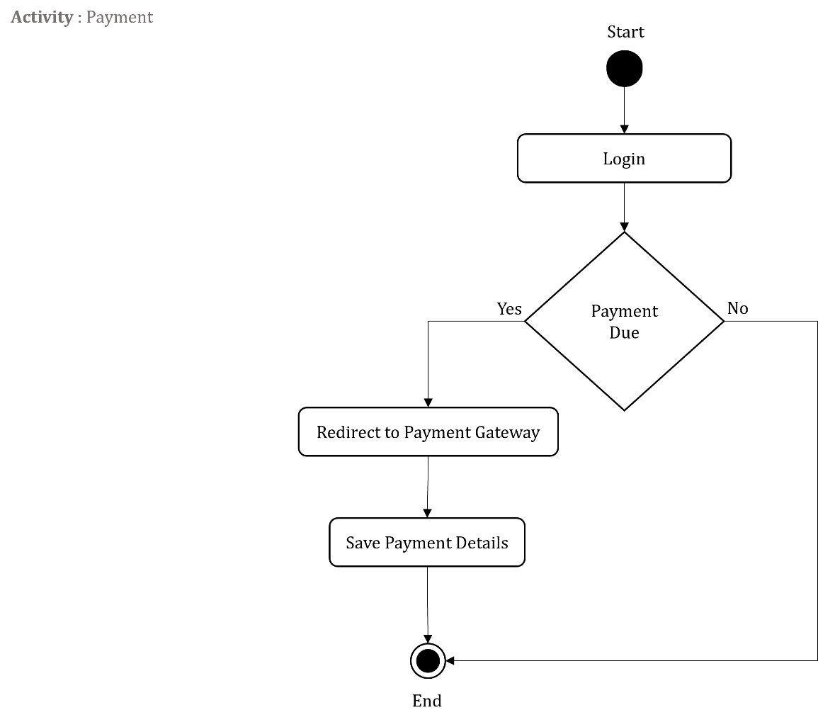

**6. Testing**

**6.1 Test Case :**

1. **Register**

|  |  |  |  |  |
| --- | --- | --- | --- | --- |
| **TestCase ID** | **TestCase Description** | **Input – n**  **( n = 1,2, ..., 11 )** | **Expected Result** | **Remark** |
| TU0001 | All Fields Valid | Valid | Redirect to Login Page | - |
| TU0002 | At Least one Field is Invalid | Invalid | Error Message. Redirect to Register Page. | Atleast one field is invalid as per it’s type. |

1. **Login**

|  |  |  |  |  |  |  |
| --- | --- | --- | --- | --- | --- | --- |
| **TestCase ID** | **TestCase Description** | **Input - 1** | **Input - 2** | **Input - 3** | **Expected Result** | **Remark** |
| TU0003 | Login into the System | Valid | Valid | Valid | Open Dashboard | - |
| TU0004 | All Credentials are Invalid | Invalid | Invalid | Invalid | Display Error Message | Invalid Credentials |
| TU0005 | Username is Invalid | Invalid | Valid | Valid | Display Error Message | Invalid Username |
| TU0006 | Password is Invalid | Valid | Invalid | Valid | Display Error Message | Invalid Password |
| TU0007 | OTP is Invalid | Valid | Valid | Invalid | Display Error Message | Invalid OTP |

1. **Add / Update Staff Member**

|  |  |  |  |  |  |  |  |  |  |  |
| --- | --- | --- | --- | --- | --- | --- | --- | --- | --- | --- |
| **TestCase ID** | **TestCase Description** | **Input - 1** | **Input - 2** | **Input - 3** | **Input - 4** | **Input - 5** | **Input - 6** | **Input - 7** | **Expected Result** | **Remark** |
| TU0011 | Add Staff | Valid | Valid | Valid | Valid | Valid | Valid | Valid | Staff member Added | Initially No Designation is Assigned |
| TU0012 | Username is already used | Invalid | Valid | Valid | Valid | Valid | Valid | Valid | Error Message. | Must use unique username |
| TU0012 | All Fields are invalid | Invalid | Invalid | Invalid | Invalid | Invalid | Invalid | Invalid | Error Message. | Must Enter all Fields. |

1. **Assign Designation**

|  |  |  |  |  |  |  |
| --- | --- | --- | --- | --- | --- | --- |
| **TestCase ID** | **TestCase Description** | **Input - 1** | **Input - 2** | **Input - 3** | **Expected Result** | **Remark** |
| TU0008 | Designation is Not assigned | Valid | Valid | Valid | Designation Assigned | - |
| TU0009 | Same Designation is assigned | Valid | Valid | Valid | Warning Message. | Designation Already Assigned |
| TU0010 | Different Designation is assigned | Valid | Valid | Valid | Designation Updated | Different Designation was Assigned |

1. **Room-Map**

|  |  |  |  |  |  |  |  |
| --- | --- | --- | --- | --- | --- | --- | --- |
| **TestCase ID** | **TestCase Description** | **Input - 1** | **Input - 2** | **Input - 3** | **Input – 4** | **Expected Result** | **Remark** |
| TU0011 | Room-Booking | Valid | Valid | Valid | Valid | Redirect to Payment Gateway | - |
| TU0012 | Package is not Selected. | Invalid | Valid | Valid | - | Warning Message. | Must Select Package |
| TU0013 | Hostel is not Selected. | Valid | Invalid | - | - | Floors and Room-map not displayed | Must Select Hostel |
| TU0014 | Hostel is not Selected. | Valid | Valid | Invalid | - | Room-map not displayed | Must Select Hostel Floor |

**6. Future Enhancement**

Hostel Management System can be upgraded to a very large scope for expansion in the near future. The Dormzz can be upgraded and developed to maintain Hostels of other Nationwide Institutes as well. The system could be upgraded to have and maintain multiple Institutes’ data, generate reports and serve its core purpose to the students accordingly. It could be made more flexible, user friendly with attractive UI and general by making it common for other similar institutions i.e. Nationwide Multiple institutions can work accordingly on the platform.

**Conclusion**

From going over this whole project development process we can get assurance that system just works amazing by bringing both students and Hostel Staff together as a Hostel is an essential part of an Institute along with educational curriculum which provides all the useful privileges to find a Hostel and book a place of their own terms that comforts them.

By digitizing the work, it will create a better workflow and we hope this system becomes useful in real world application.

**Bibliography**

1. Object Oriented Software Engineering by Yogesh Singh and Ruchika Malhotra

2. Software Engineering A practitioner’s approach by Pressman

3. Steven Holzner, The Complete Reference PHP, Mc Graw Hill.

**Other Reference:**

1. Hugh E. Williams, PHP and MySQL, O’Reilly. [HW]

2. Sharanam Shah, Vaishali Shah - Java EE 6 Server Programming, Shroff publishers & Distributors - [SV]

3. http://php.net/manual/en/

4. http://api.jquery.com/Ajax_Events/

5. <https://learn.jquery.com/ajax/jquery-ajax-methods/>

6. <https://business.paytm.com/docs>

**- Thank you -**